Maritime Vessel Tracking System(Team - 3)
Project Documentation
Last Updated: 19 February 2026 (Milestone-1)

Team3 - Members
1- Sushant Pathak (Team Lead)--(Backend + db+ integration)
2- Satayma (front-end + db)
3- Rishwita nangunri –(frontend)
4- Bandewar Aditya datta (Backend)
5- Veerababu db + integration)

1. Introduction
The Maritime Vessel Tracking System is a full-stack web application developed to track vessels, monitor port congestion, manage voyages, and generate safety alerts.
The system consists of:
- A Django REST API backend
- A React (Vite) frontend
- A relational database (SQLite for development)
It is designed to simulate real-world maritime monitoring platforms used for fleet management, analytics, and operational decision-making.

2. Objectives
The main objectives of this project are:
- To build a scalable REST API using Django and Django REST Framework
- To implement secure user authentication using JWT
- To design a modern frontend using React
- To structure the project using modular architecture
- To integrate external maritime data sources
- To simulate vessel tracking, port congestion monitoring, and voyage analytics

3. System Architecture
React Frontend → Django REST API → Database
↓
External Integrations
Components
3.1 Frontend (React + Vite)
- Handles UI and user interaction
- Manages authentication state
- Sends API requests to backend
3.2 Backend (Django + DRF)
- Processes API requests
- Handles authentication and authorization
- Manages database operations
- Runs background tasks
3.3 Database
- Stores users, vessels, ports, voyages, notifications, and related data
- SQLite is used for development

4. Technology Stack
Backend
- Python
- Django
- Django REST Framework
- JWT Authentication
- SQLite (Development)
Frontend
- React
- Vite
- Tailwind CSS
- Axios

5. Features Implemented
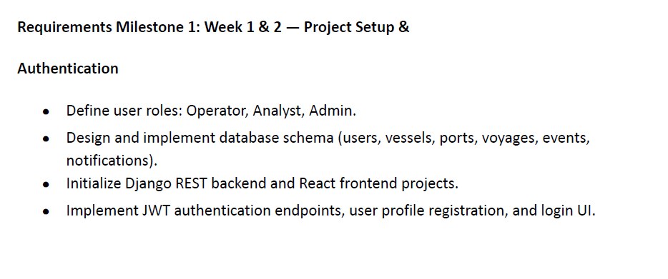
5.1 Authentication System
- User registration
- Login using JWT
- Role-based access control
- Token storage in localStorage
- Logout functionality
- Profile management
- Update profile
- Change password
Custom user/profile models, serializers, permissions, signals, and unit tests are implemented in the authentication app.
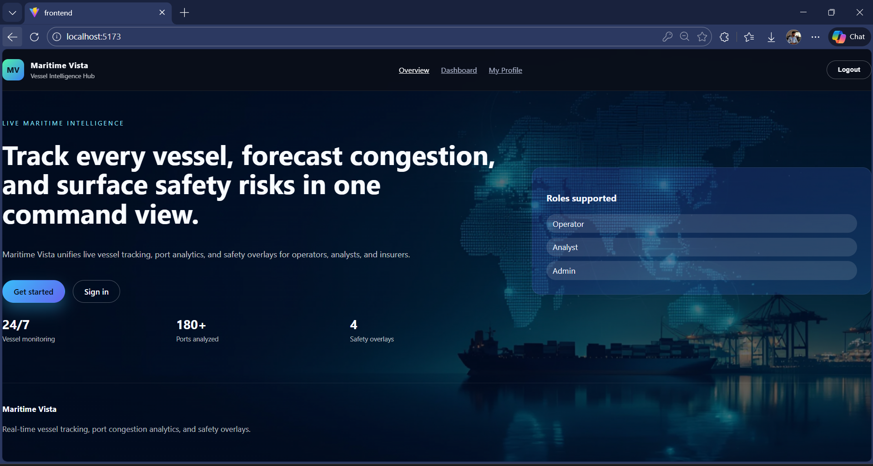
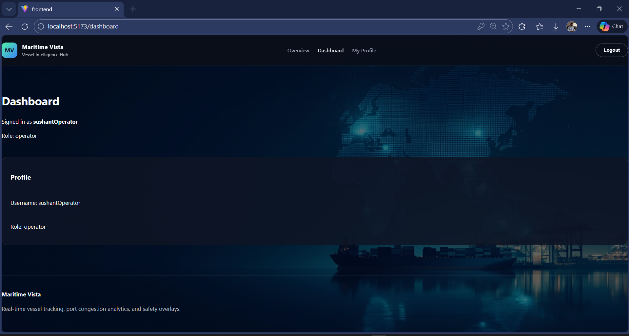
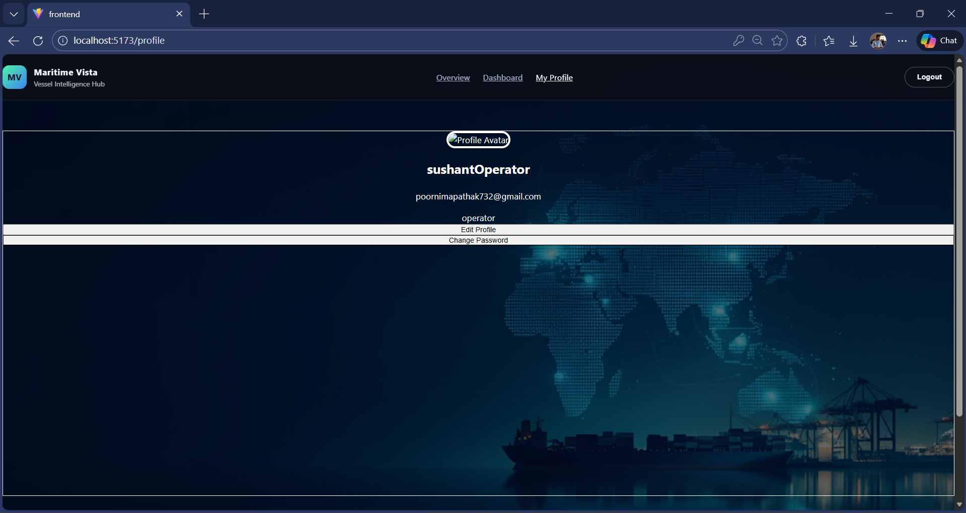

6. API Endpoints (Examples)
Authentication
Method | Endpoint | Description
POST | /auth/register/ | Register new user
POST | /auth/login/ | Login user
GET | /auth/profile/ | Get logged-in user

Endpoint | Description
/admin/ | Django Admin Panel
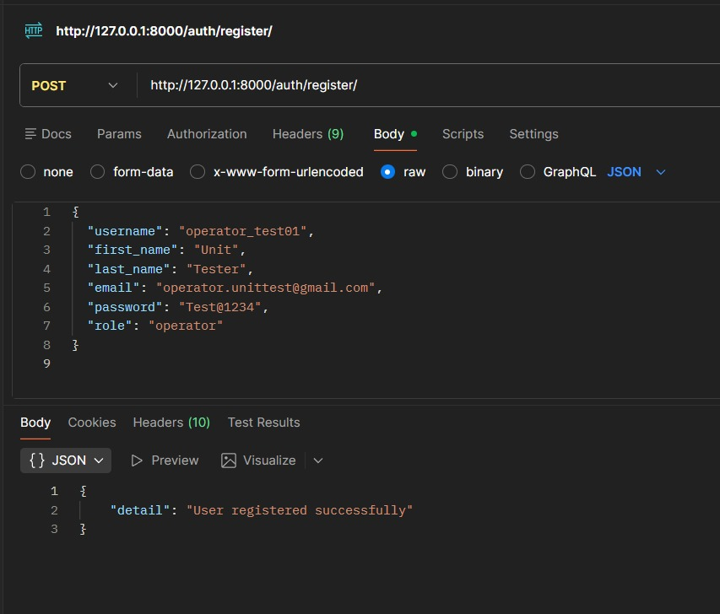

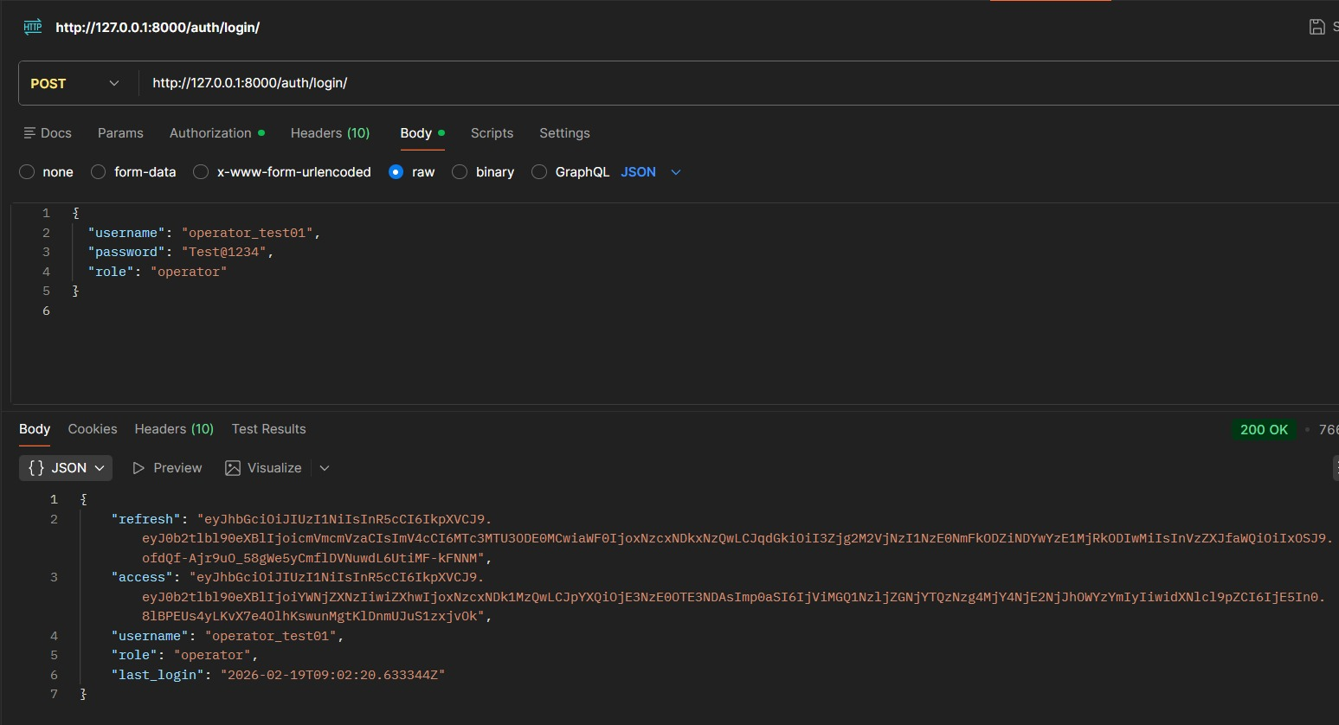
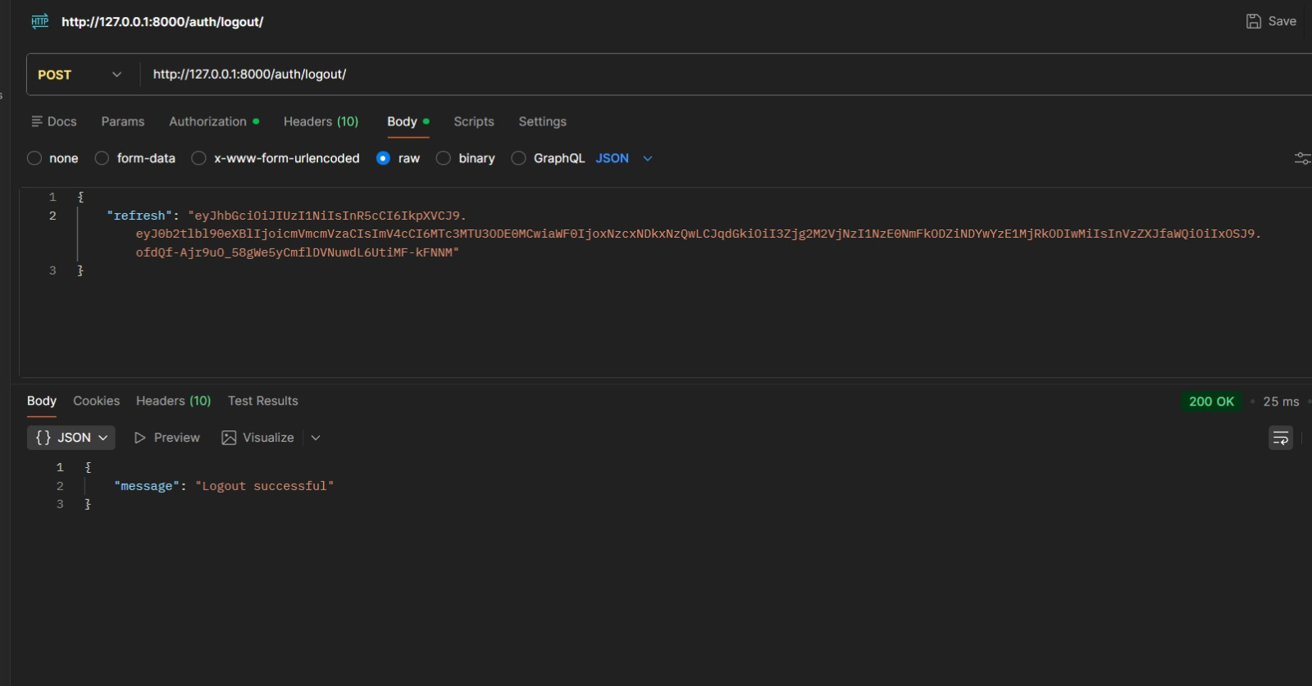

8. Setup Instructions
8.1 Backend Setup
- Create virtual environment:
python -m venv .venv
.\.venv\Scripts\activate
- Install dependencies:
pip install -r backend/requirements.txt
- Run migrations:
python backend/manage.py migrate
- Create superuser:
python backend/manage.py createsuperuser
- Run server:
python backend/manage.py runserver
Backend runs at:
http://127.0.0.1:8000

8.2 Frontend Setup
- Navigate to frontend:
cd frontend
- Install dependencies:
npm install
- Run development server:
npm run dev
Frontend runs at:
http://localhost:5173

9. Authentication Flow
- User registers via frontend
- Backend validates request data
- JWT token is generated
- Token stored in browser localStorage
- Token attached in Authorization header for protected routes

10. Database Design (High-Level)
Main tables include:
- User
- Role
- Vessel
- Port
- Voyage
- Notification
Relationships
- User → Role
- Vessel → Voyage
- Port → Vessel
- User → Notification

11. Security Measures
- JWT-based authentication
- Password hashing
- Role-based access control
- Environment variable configuration
- Debug mode disabled in production

13. Future Improvements
- Real-time WebSocket vessel tracking
- Interactive map integration
- Advanced analytics dashboard
- Full PostgreSQL production deployment
- CI/CD integration
- Scalable background job processing

14. Conclusion
The Maritime Vessel Tracking System demonstrates:
- Full-stack development
- Secure authentication system
- Modular backend architecture
- REST API design
- Integration with external data sources
- Background task processing
- Containerization support
This project can be extended into a production-level maritime analytics and fleet monitoring platform.

